**ASCII**

The CPU of the computer understands only binary numbers - zeros and ones. How does it print these letters on the screen? How does it understand my Python script?

***ASCII*** ( pronounced *ASS-KEY*, ***for American Standard Code for Information Interchange***) is a code that translates characters (letters, numbers and punctuation) into numbers. Each character is given a numerical value. Here is the first half of the ASCII code in a table format:

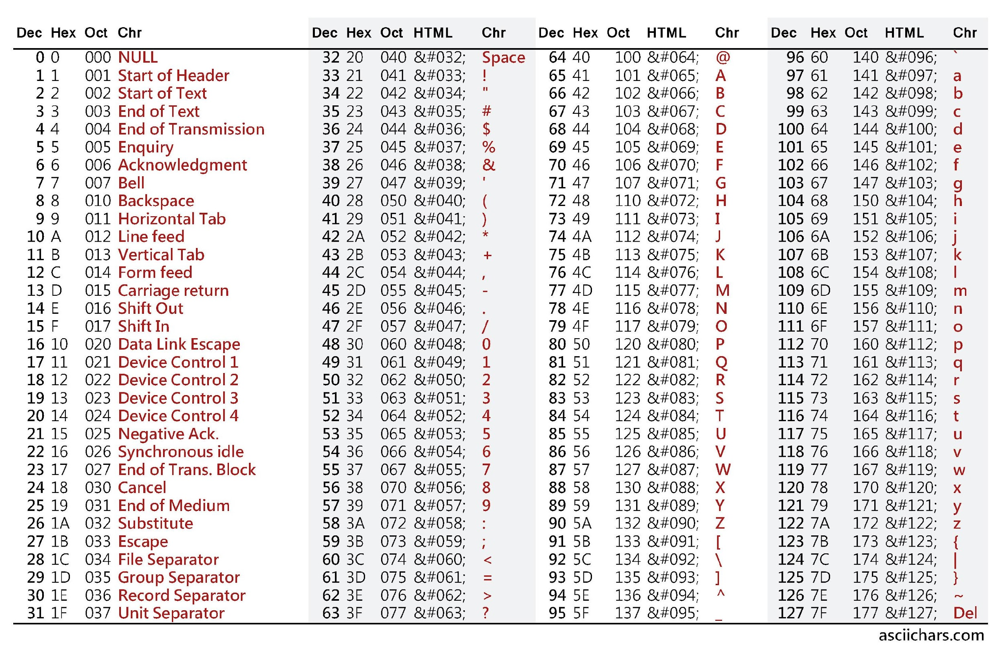

*Source*: <http://www.asciitable.com/>

ASCII is a very old standard used to convert keyboard characters into a numerical code. In the table above, the characters are in red and the ASCII code is given in decimal (first column in **bold**), hexadecimal and Octal (2nd and 3rd column).

The first set of red "characters" are communication characters - for communicating between devices like a printer and a computer. The alphabet doesn't begin until ASCII code 65 (for the letter “A”).

The table shows the first half of the ASCII code. The second half of the code deals with extended characters such as foreign language symbols (e.g. the French é, è and ç), monetary symbols (¢, £, ¥) and so on.

In Python, to convert a number to an ASCII character, use the **ord**() function:

print ("The ASCII code for the letter 'a' is ", end="")

print (ord('a')) # gives the ASCII code for letter “a”

The ord() function (ord stands for “ordinal” which means “number”) will return the ascii code for the character.

To convert from ASCII code to character, use the **chr**() function:

print ("The ASCII character for code #97 is: ", end="")

print (chr(97)) # prints “a”

The chr() function (chr is short for “character”) returns the character represented by that number. There are 256 characters in all (numbered 0 to 255). You can print out all the characters using a for loop:

for i in range (256):

print (chr(i), end="") # print the characters out

if i % 32 == 0: # what is

print() # this for ?

What is the purpose of the if statement? Remove (or comment out) the last two lines to understand what they do.

**Unicode**

ASCII is a code first established in the 1950s. It is an 8 bit code, meaning that it can only remember ______ symbols (you figure it out!). There is a more modern version of ASCII, called Unicode. Unicode is a 16 – bit system, which means it can handle _________ different characters. This enables it to show international language symbols such as Arabic. Shukran!

**Keywords**: ***ASCII, American Standard for Information Interchange,***